User Manual

Maharat Program - Training Providers

Login to the National Labor Gateway 'TAQAT'

Login as a Training Provider



Login to the National Labor Gateway 'TAQAT'

To Create a New User Account, select New User https://eservices.taqat.sa/Eservices/home.asp



Login to the National Labor Gateway 'TAQAT'

Select Training Provider Type

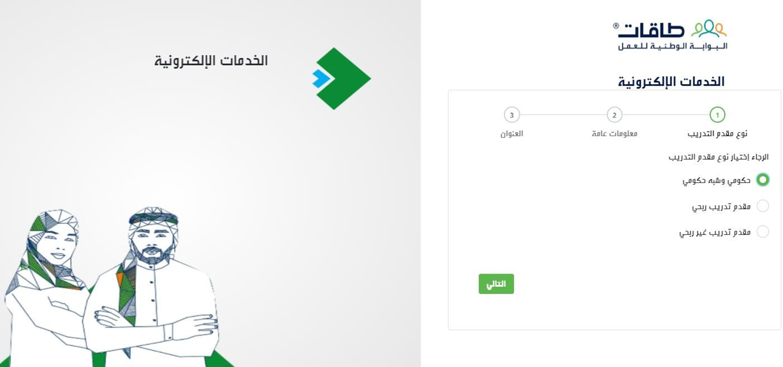

Login to the National Labor Gateway 'TAQAT'

Fill Out All Required Entry Fields



Login to the National Labor Gateway 'TAQAT'

Upload Required Documents to Complete Your Verification

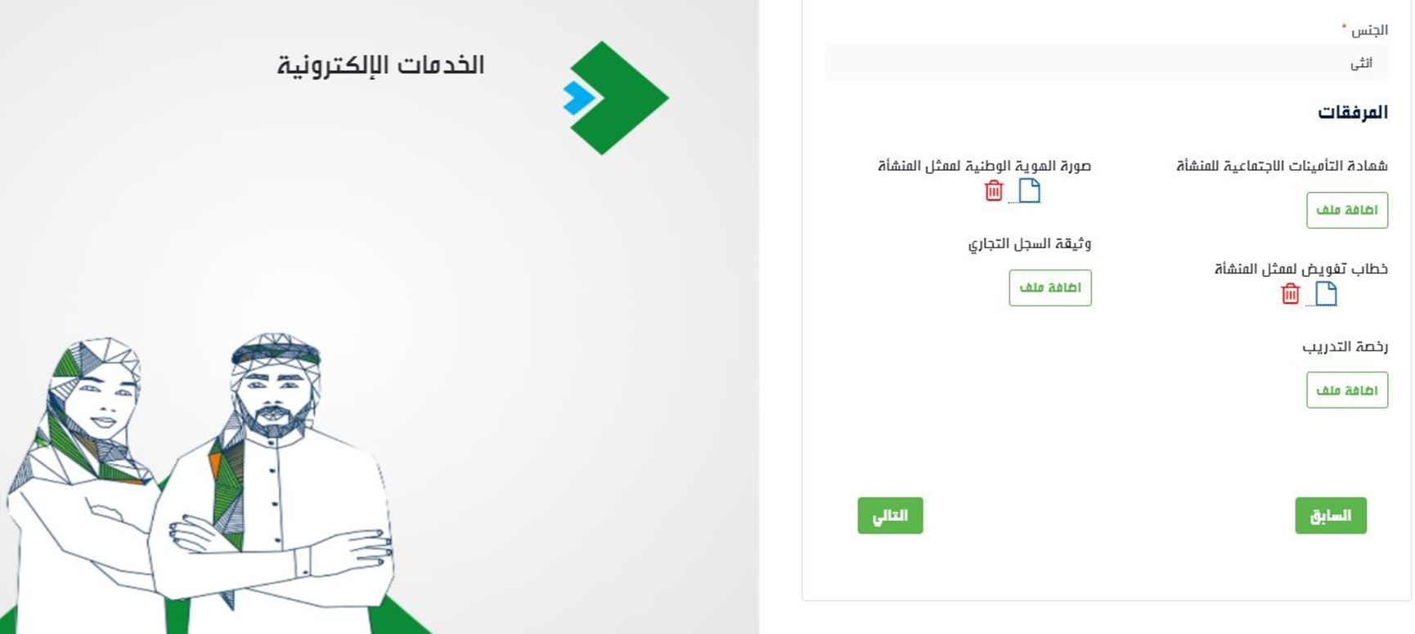

Login to the National Labor Gateway 'TAQAT'

Enter and Set the Address on Google Maps

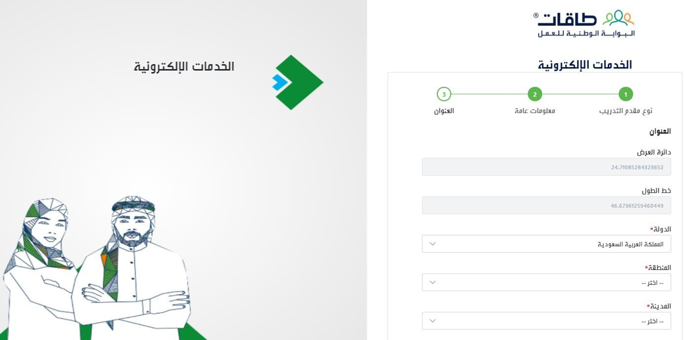

Login to the National Labor Gateway 'TAQAT'

Agree to the Terms and Conditions and Confirm Your Login



Login to the National Labor Gateway 'TAQAT'

Enter your Username and Password


Login to the National Labor Gateway 'TAQAT'

Enter Verification Code
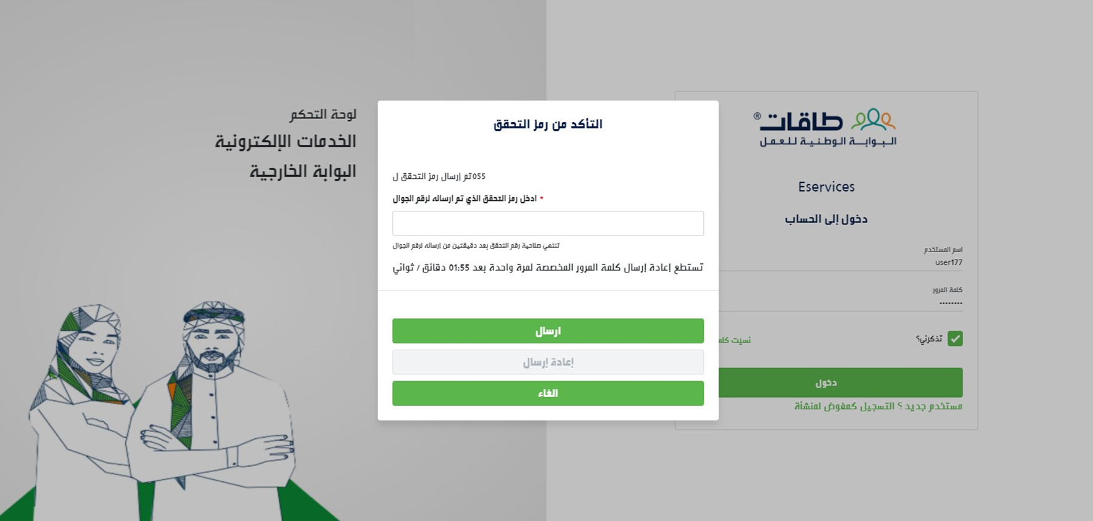

Establishment Profile
Check the Establishment Profile with TAQAT to View or Edit

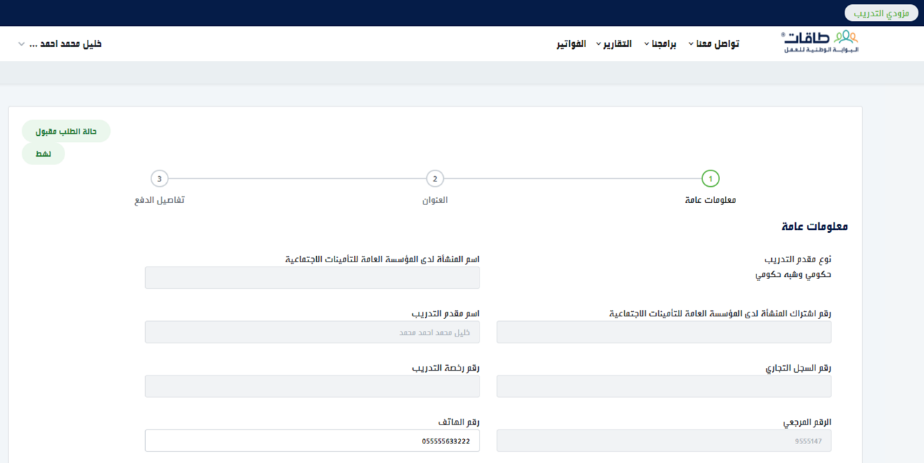

Log in to Maharat Program
Go to Our Programs > Maharat > Courses
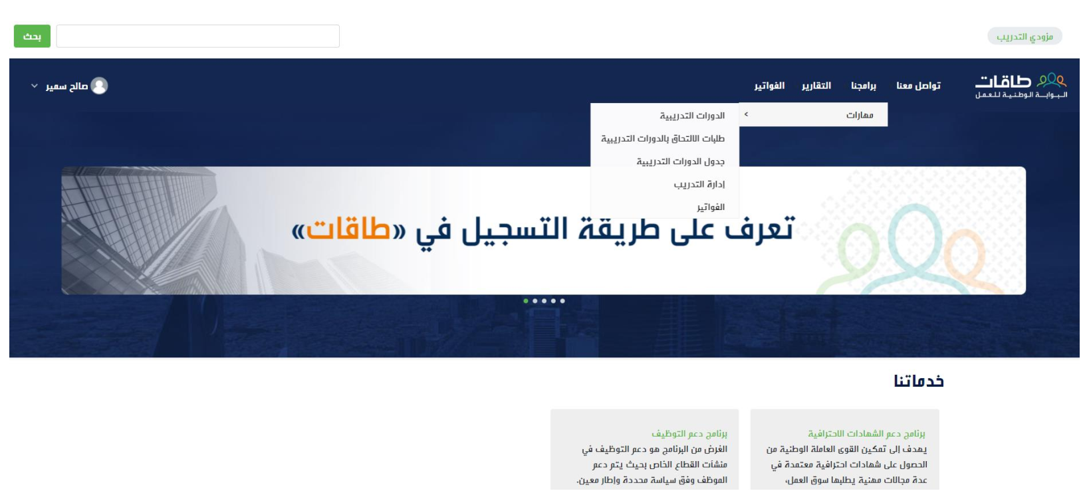

Courses
Add a New Course
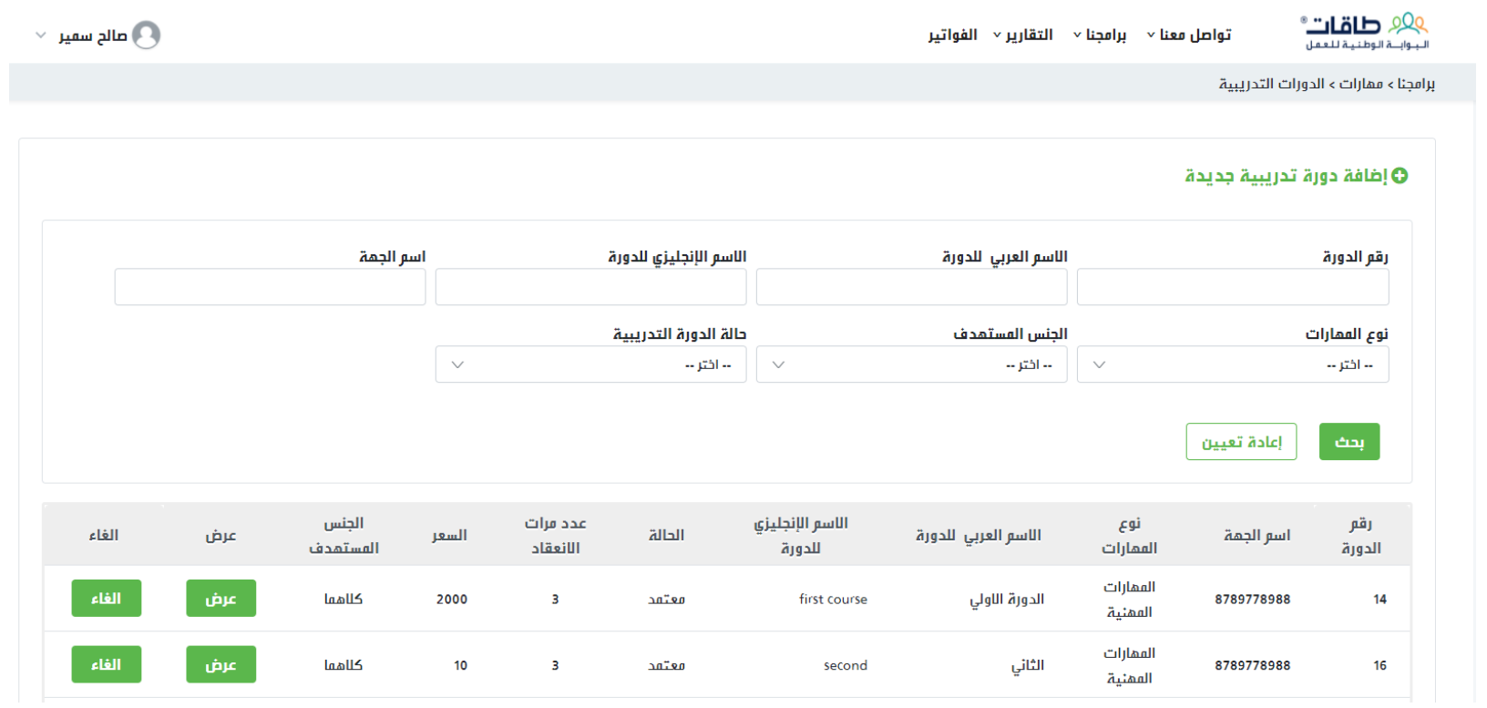

Courses
Agree to the Terms and Conditions
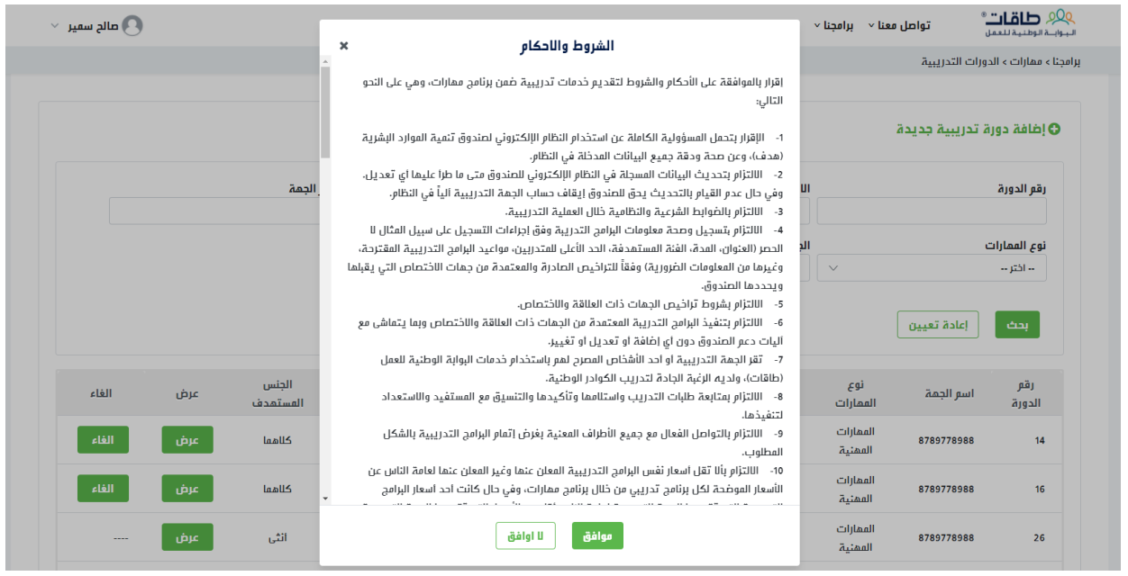

Courses
Enter all the Details of the New Course
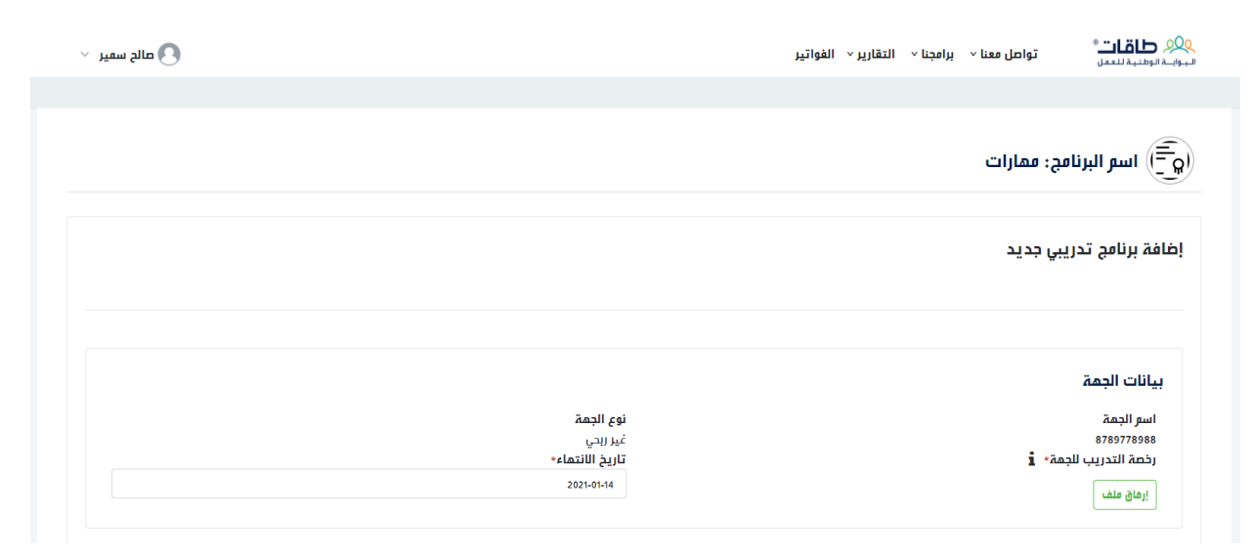

Courses
Enter all the Details of the New Course
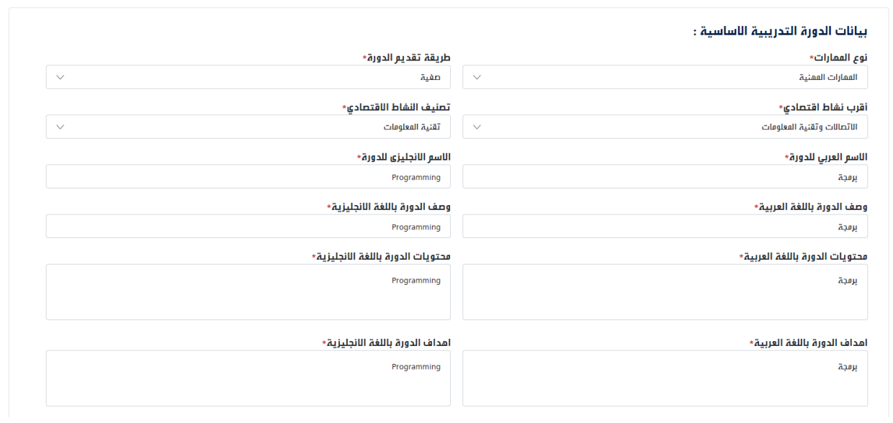

Courses
Enter all the Details of the New Course
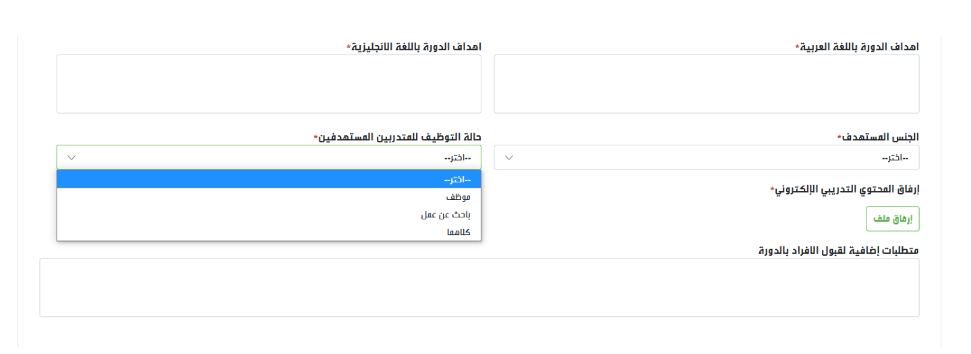

Courses
Enter all the Details of the New Course (Classroom Training)
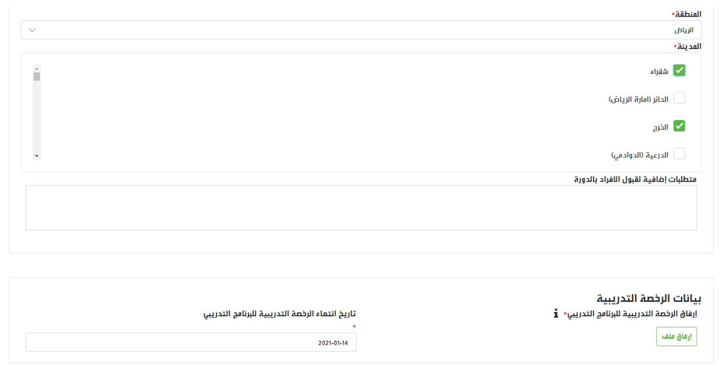

Courses
Enter all the Details of the New Course (Online Training)
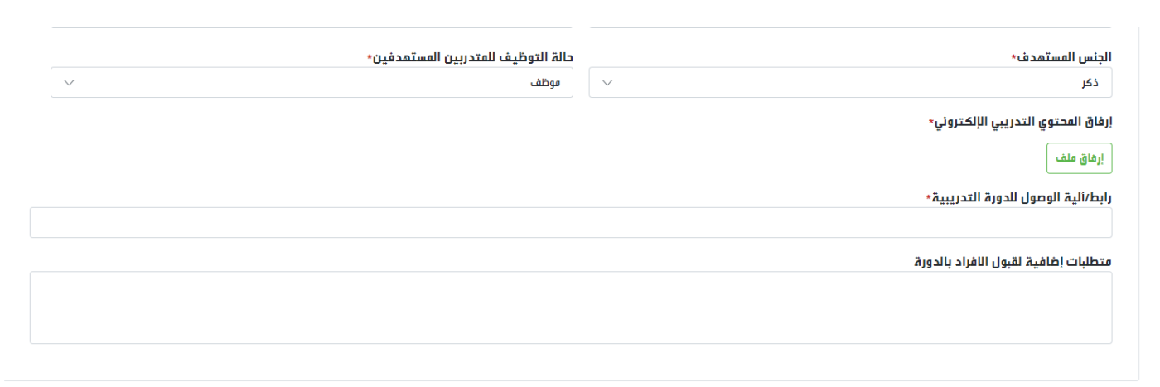

Courses
Enter all the Details of the New Course
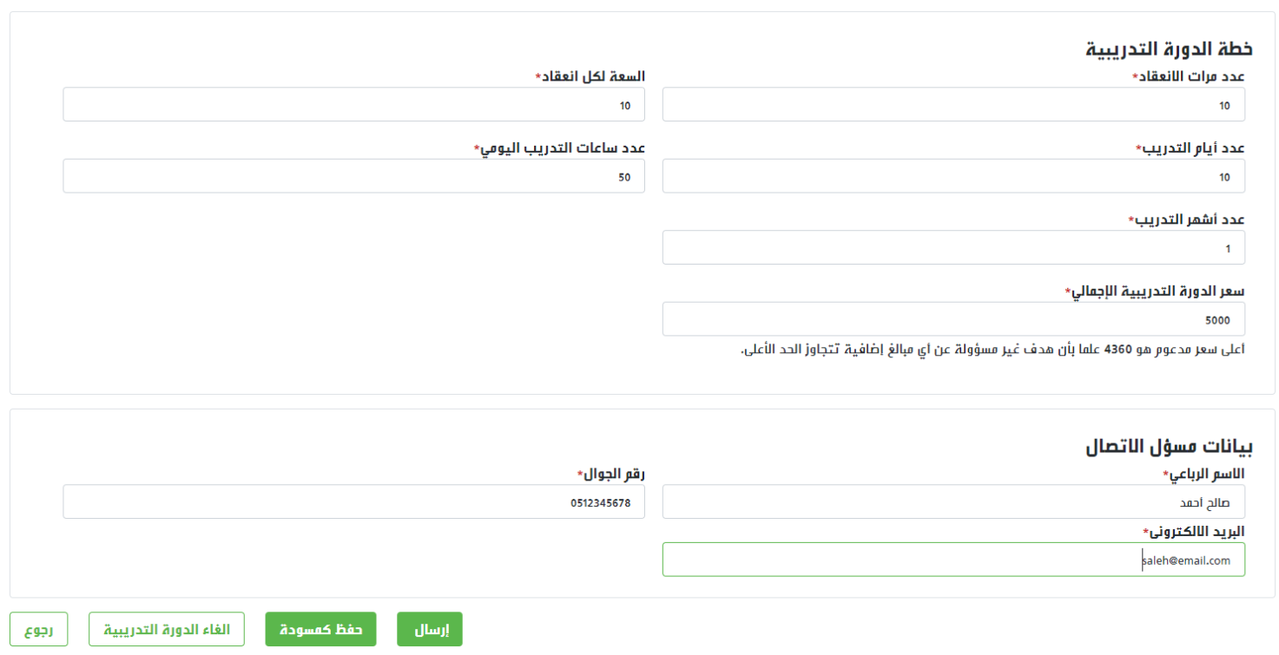

Courses
Comply with the Daily Training Hours Requirements:
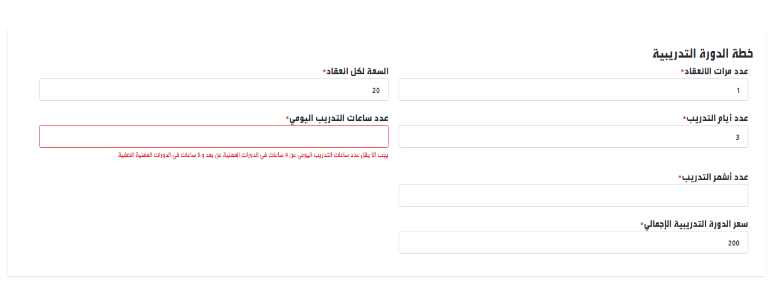

Courses
Save the Course Details and Send them for Approval
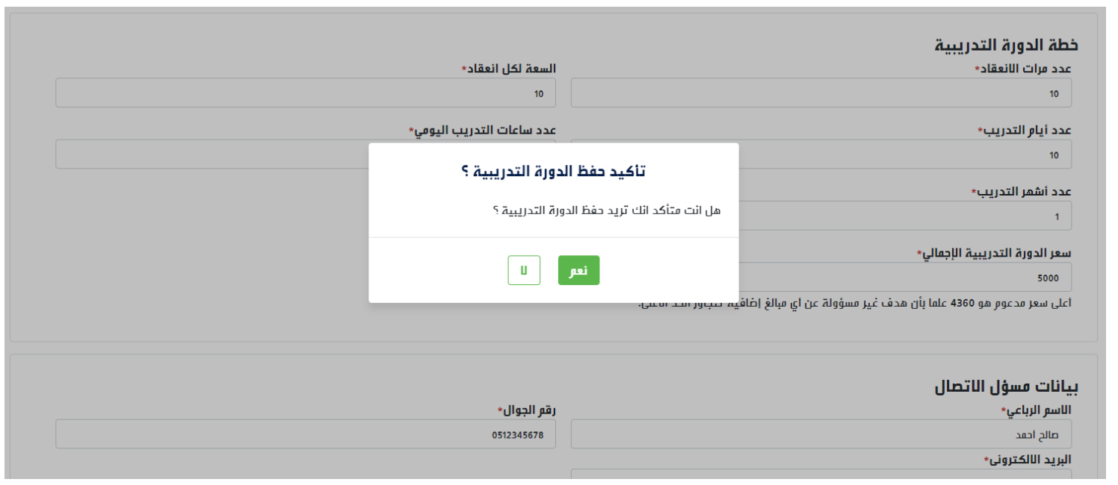

Courses
Save the Course Details
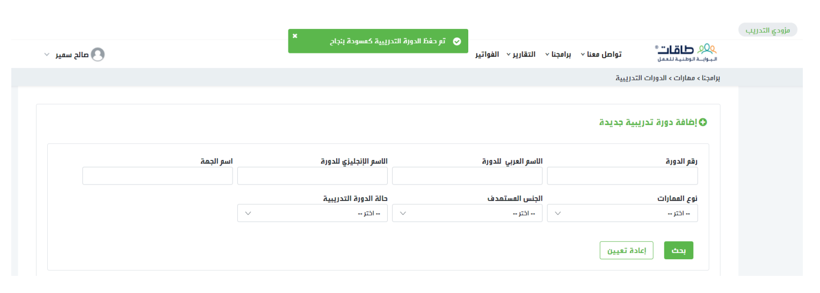

Courses
Send the Course to be Approved by the Program Administration at the Human Resources Development Fund (HADAF)
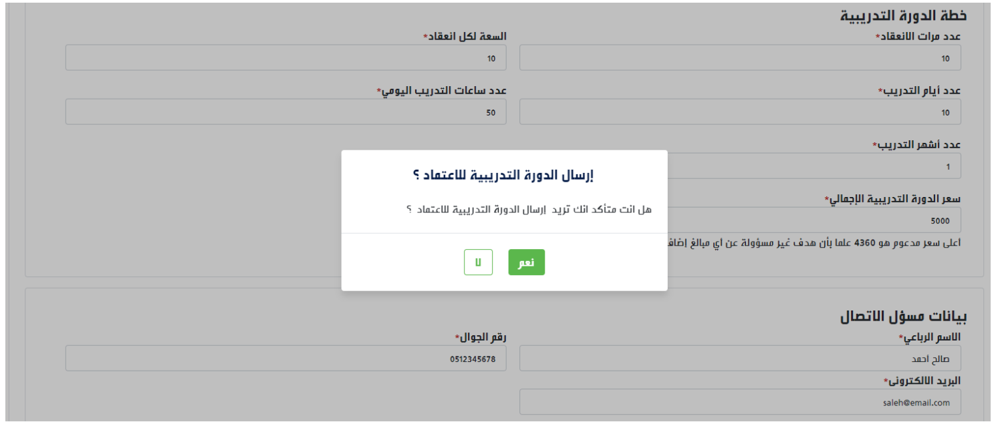

Courses
Send the Course to be Approved by the Program Administration at the Human Resources Development Fund (HADAF)
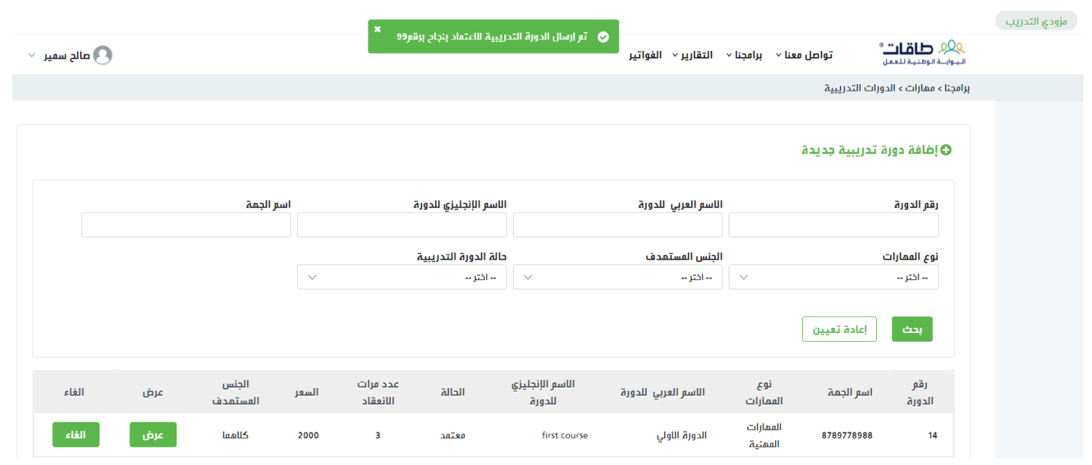

Courses
After being approved, the course status will be changed to Approved
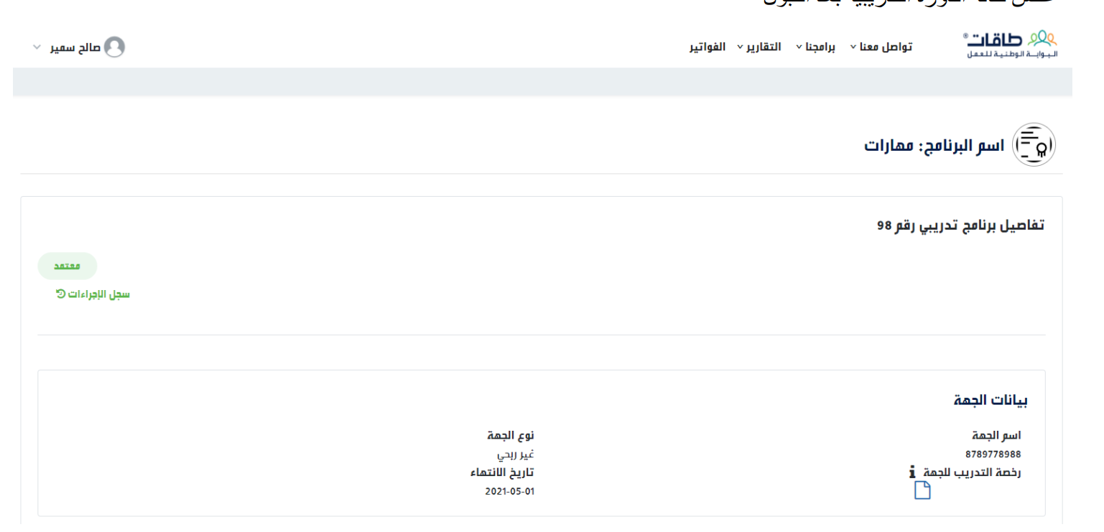

Courses
If approval is not granted, the course status will be changed to Rejected, with indicating the reason for rejection.
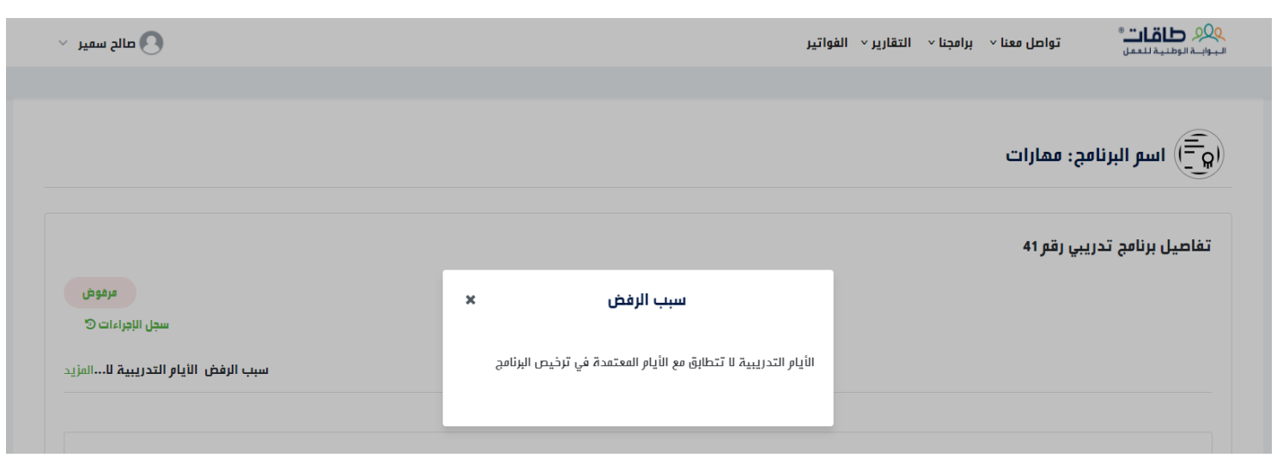

Courses
You can cancel the course
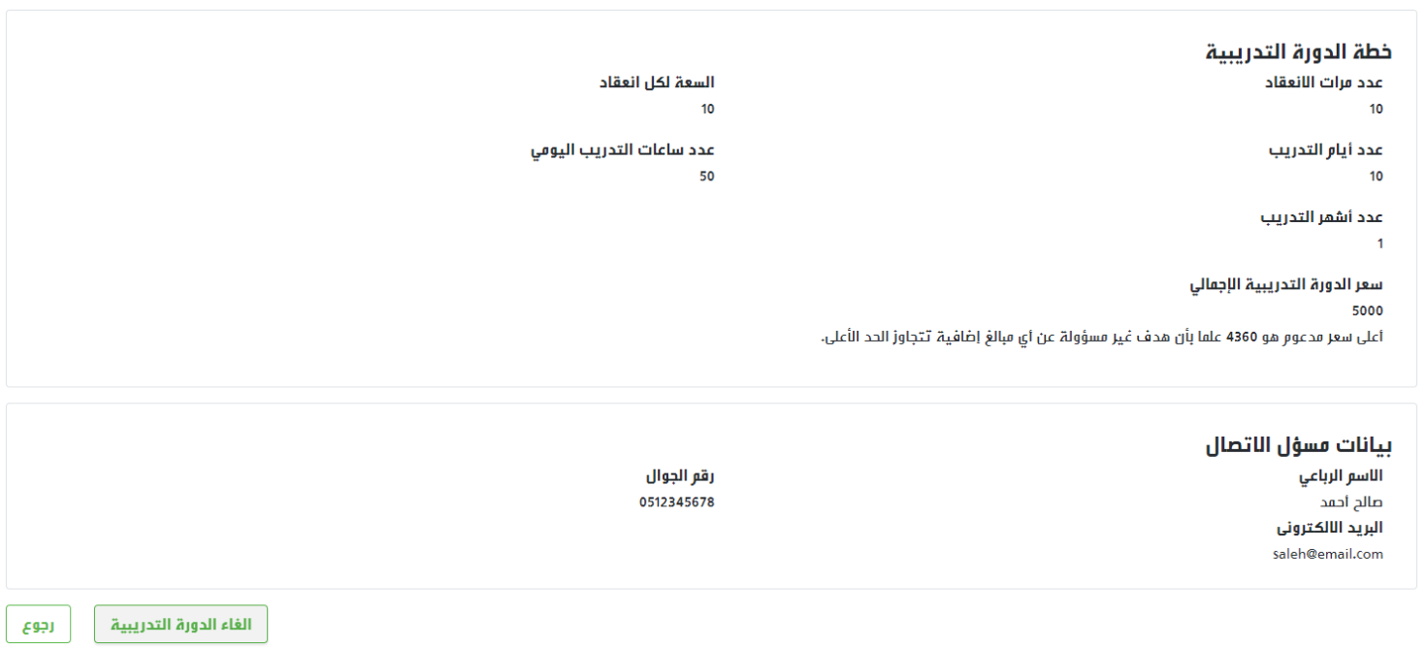

Courses
Search for any saved or previously sent course
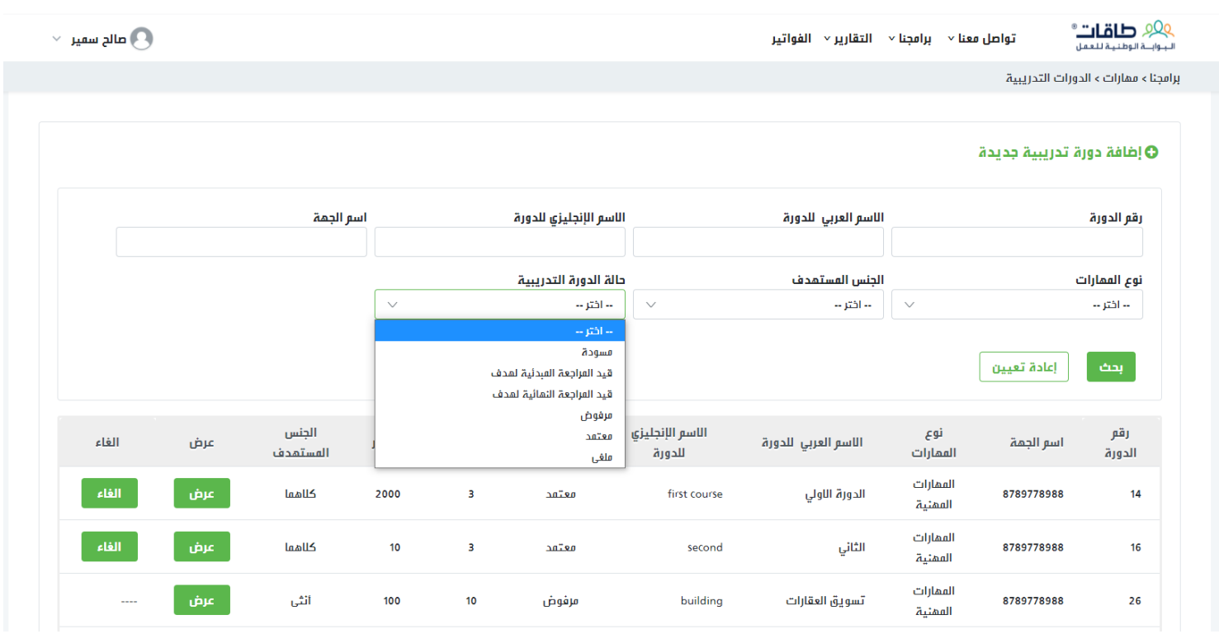

Course Schedule
Go to Our Programs > Maharat > Course Schedule
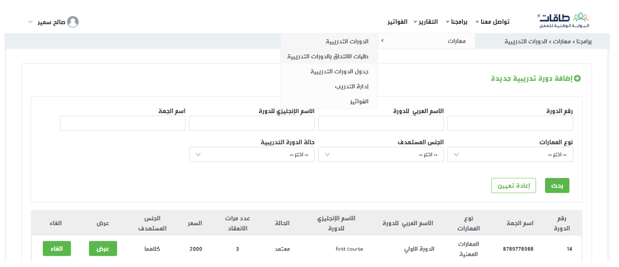

Course Dates
Add a new date
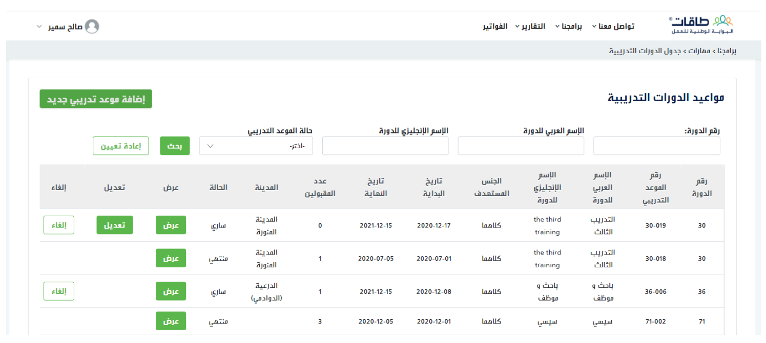

Course Dates
Add a new date
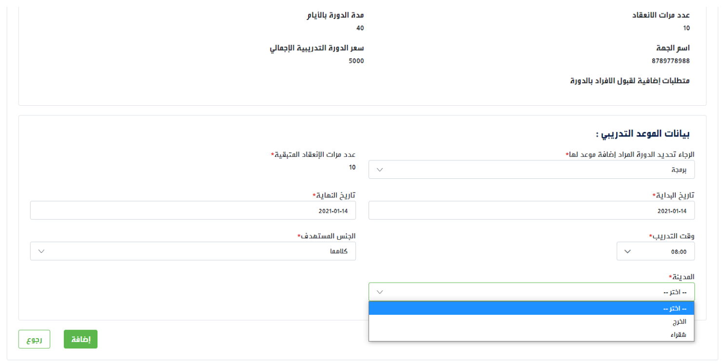

Course Dates
Add a new date
Number of New Training Days ≥ Number of Previous Days
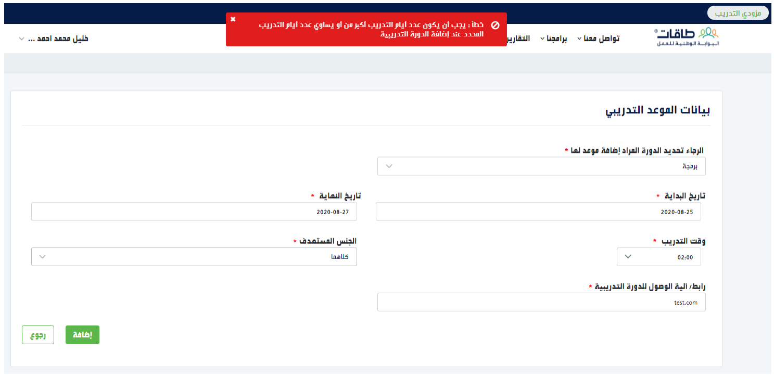

Course Dates
Add a new date
Check the validity of the training program license
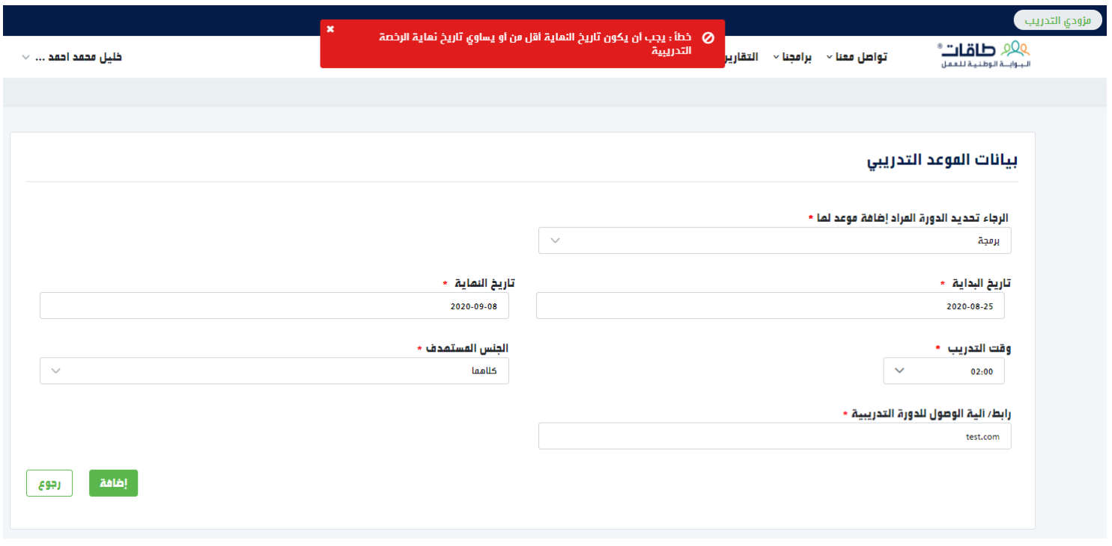

Course Dates
Add a new date
The number of sessions previously entered in the course cannot be exceeded.
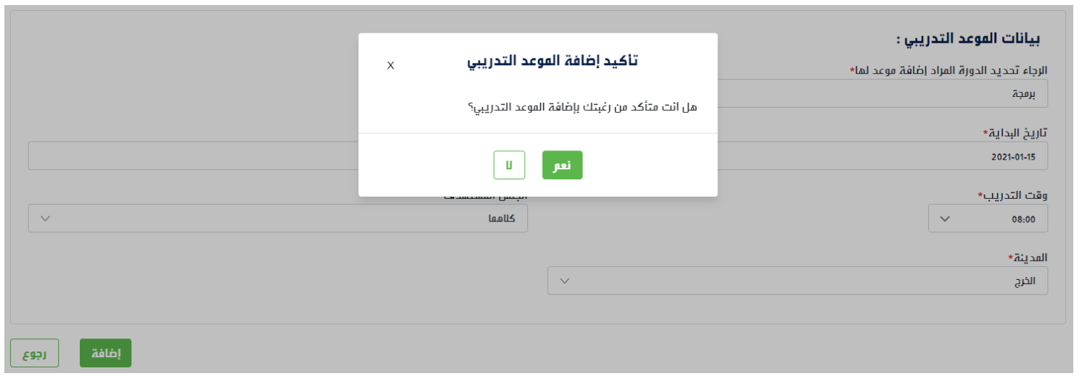

Course Dates
Add a new date
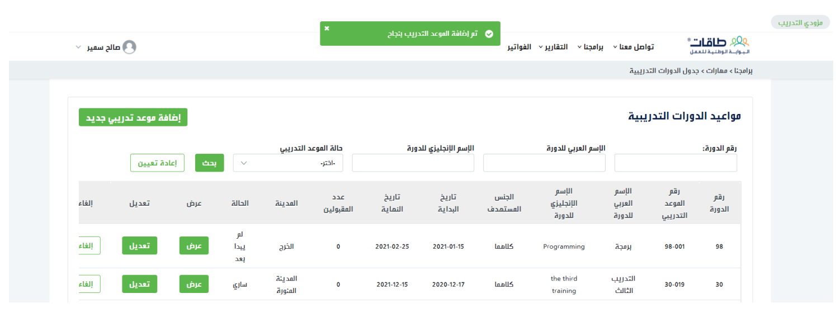

Course Dates
View the schedule of all courses and search by status
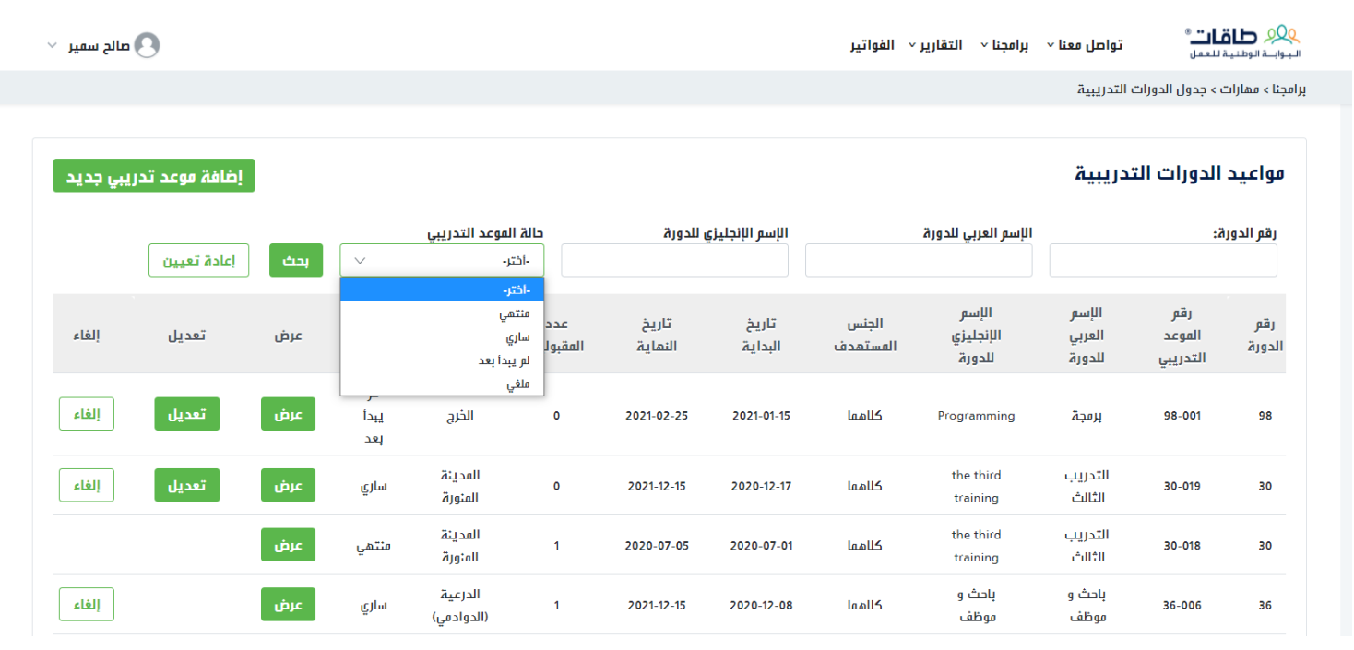

Course Dates
To cancel a course date, select (Cancel).
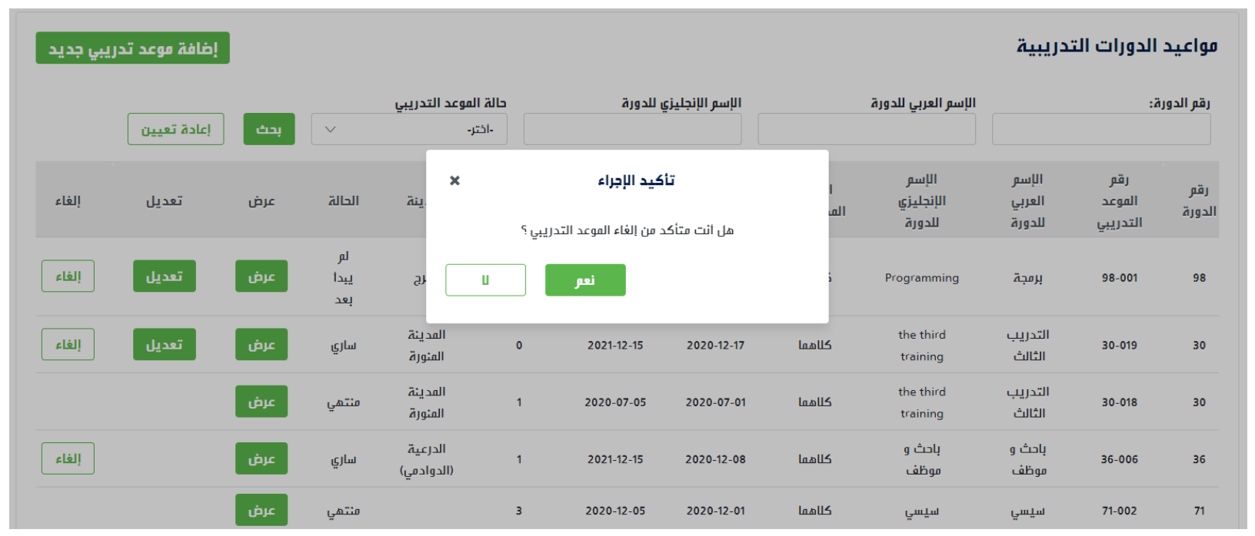

Course Dates
To cancel a course date, select (Cancel).
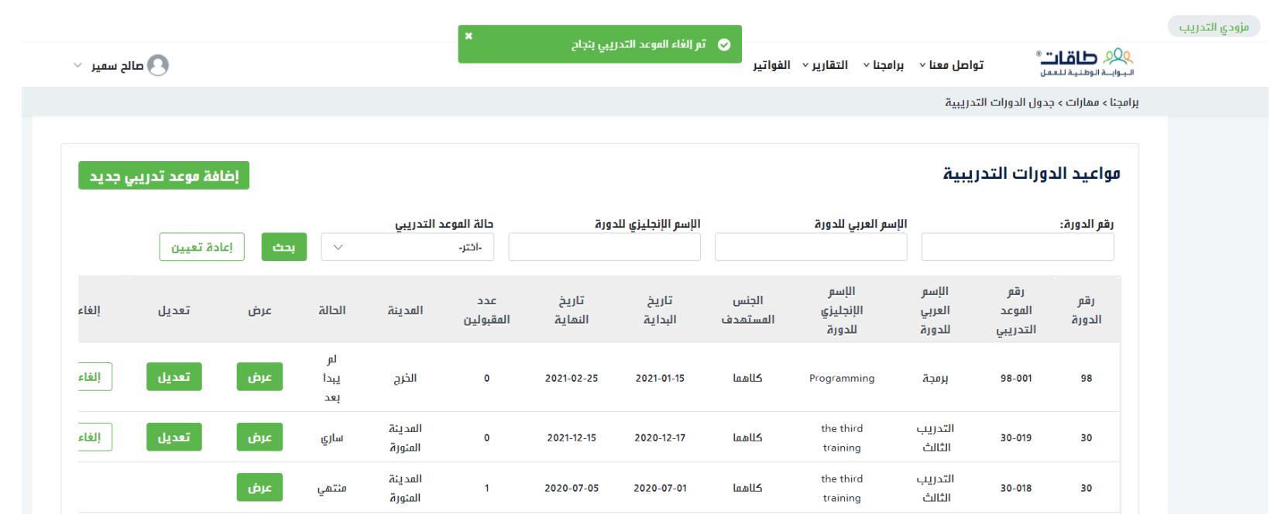

Course Dates
The course date cannot be canceled if there are accepted trainees and as long as the training program is not finished / completed.
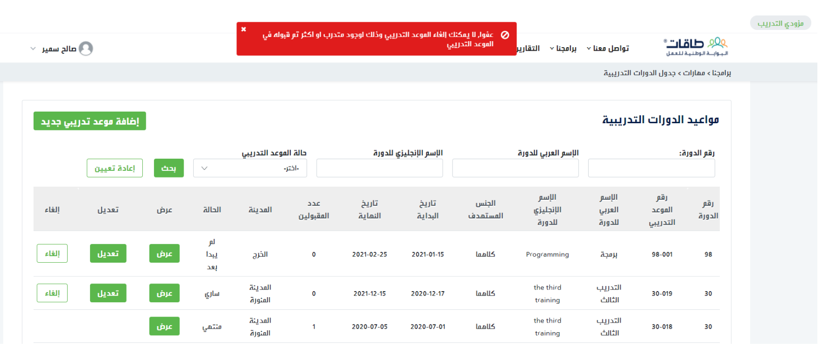

Course Applications
Go to Our Programs > Maharat > Course Applications
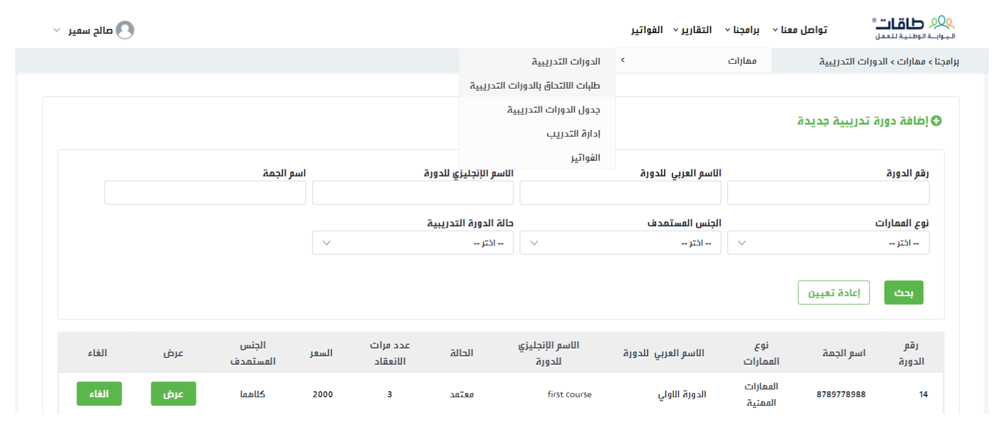

Course Applications
View all applications sent by individuals, to review the details of any applicant, click (View)
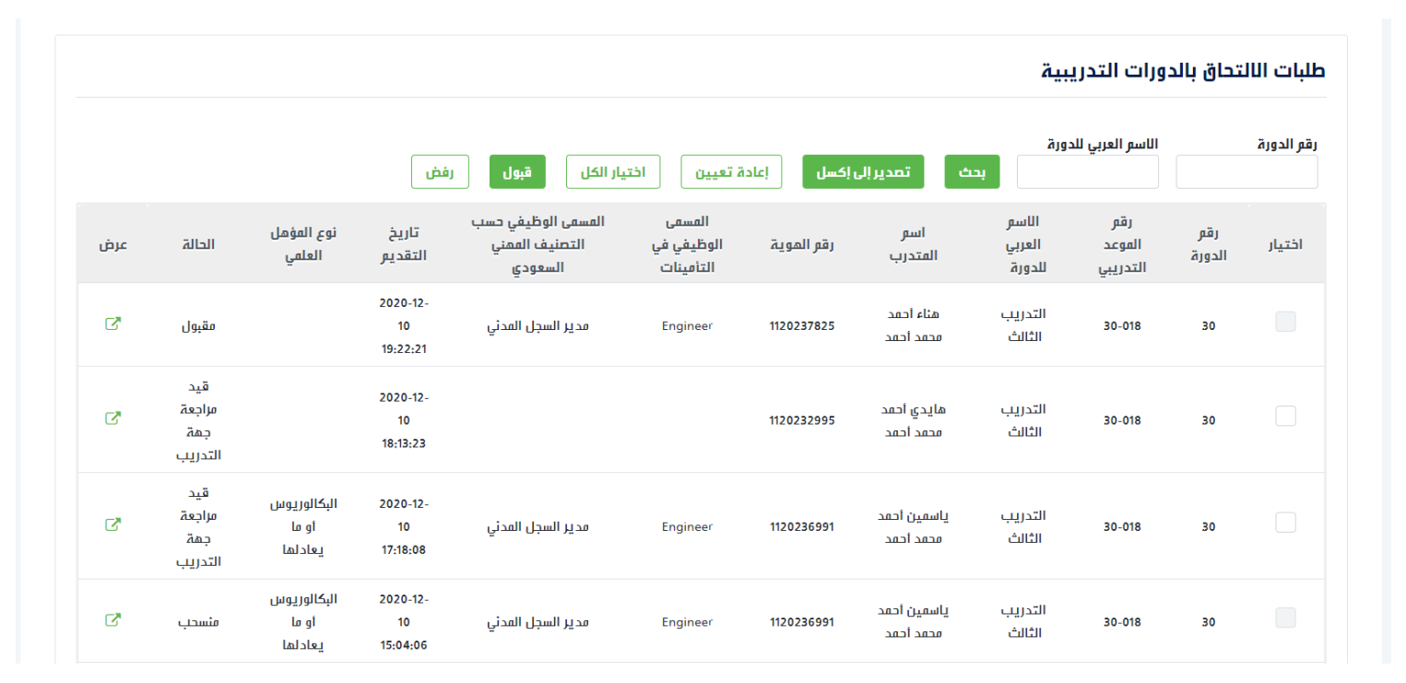

Course Applications
Review the details of the applicant for the course
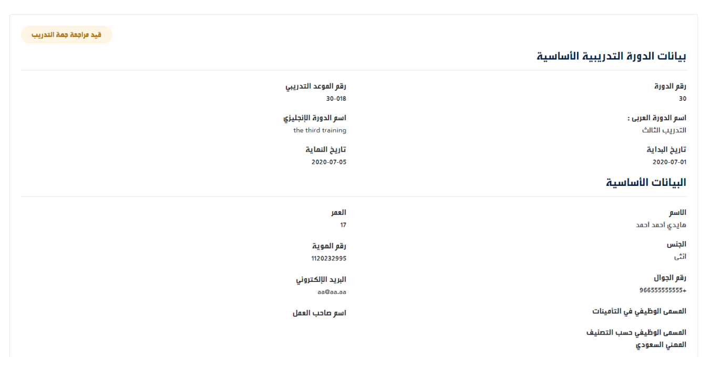

Course Applications
Accept the Course Application
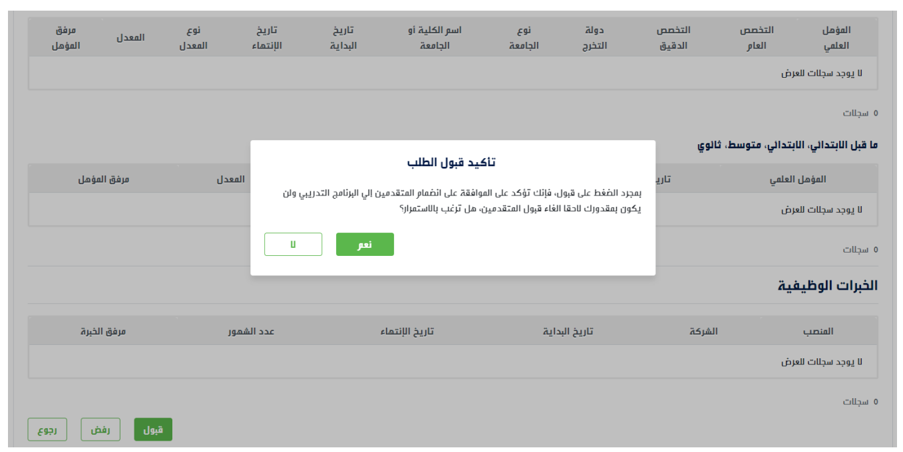

Course Applications
Accept the Course Application
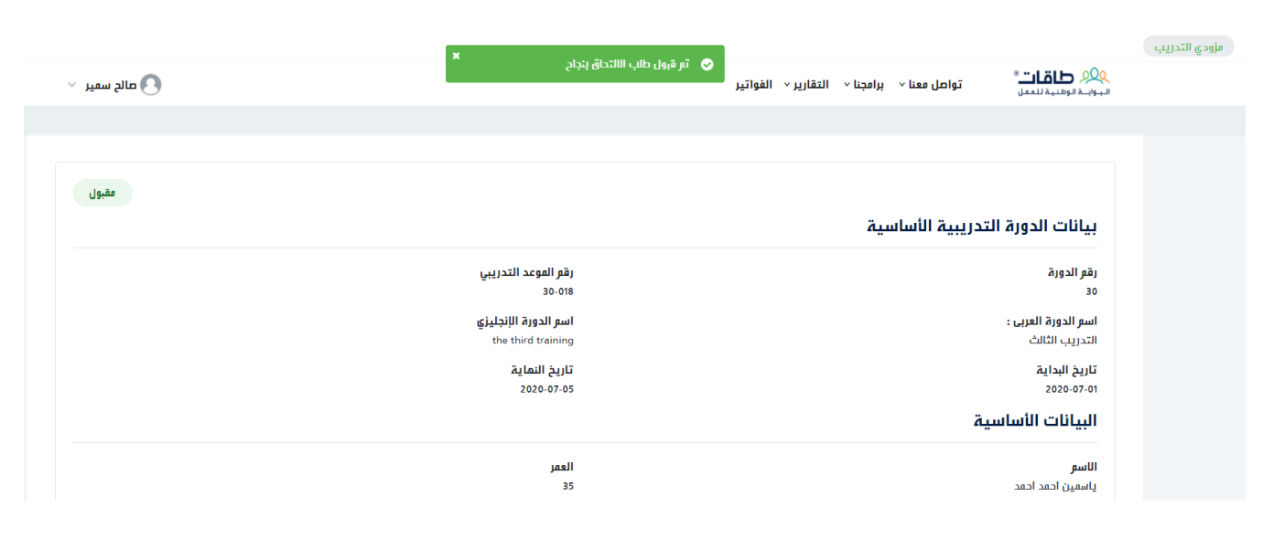

Course Applications
Reject the Course Application, with choosing the reason for rejection.
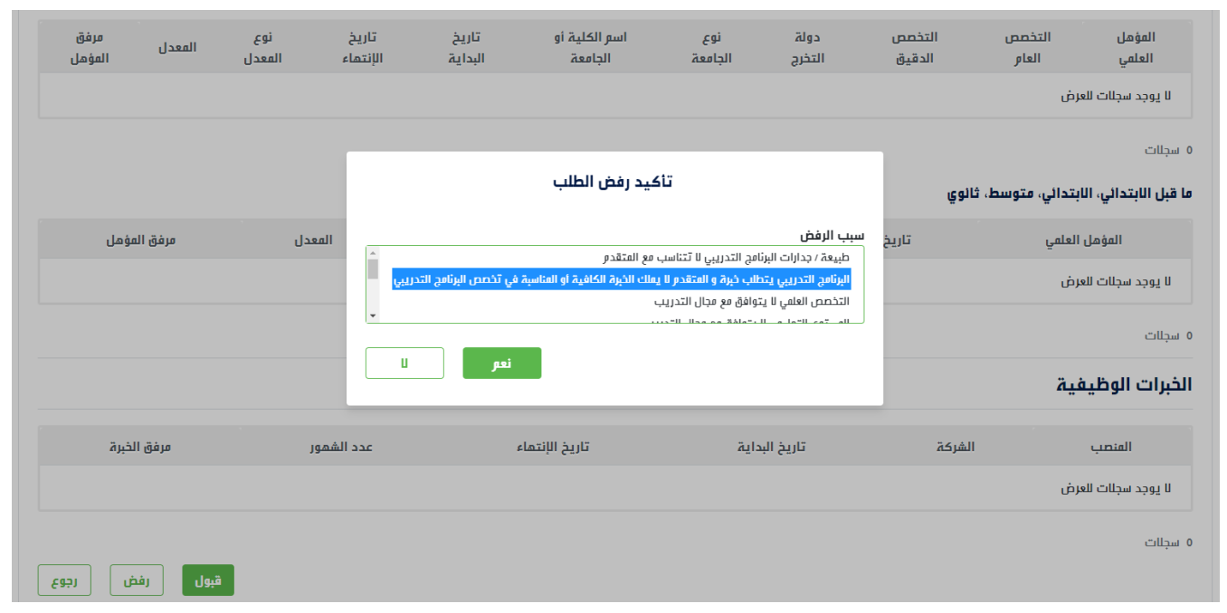

Course Applications
The applicant can withdraw from the course if approval has not been given by the training provider yet. In such a case, the entered reason for withdrawal will appear.
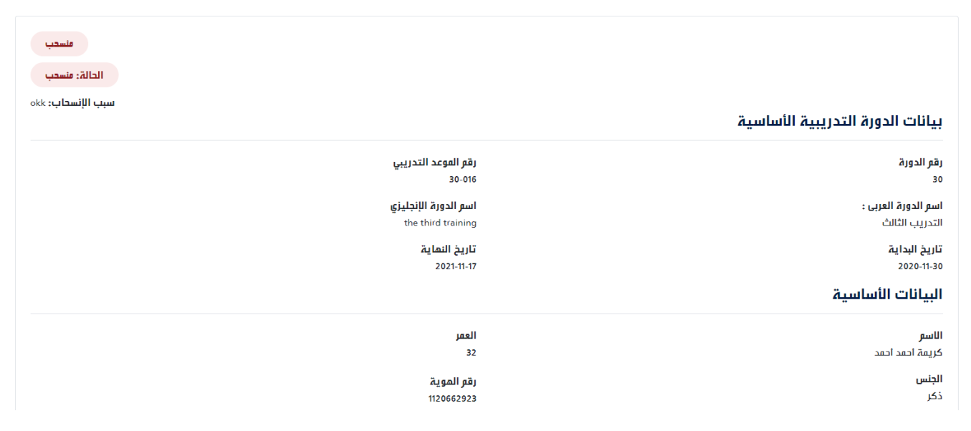

Course Applications
The details of the applicants for training programs can be exported to Excel.
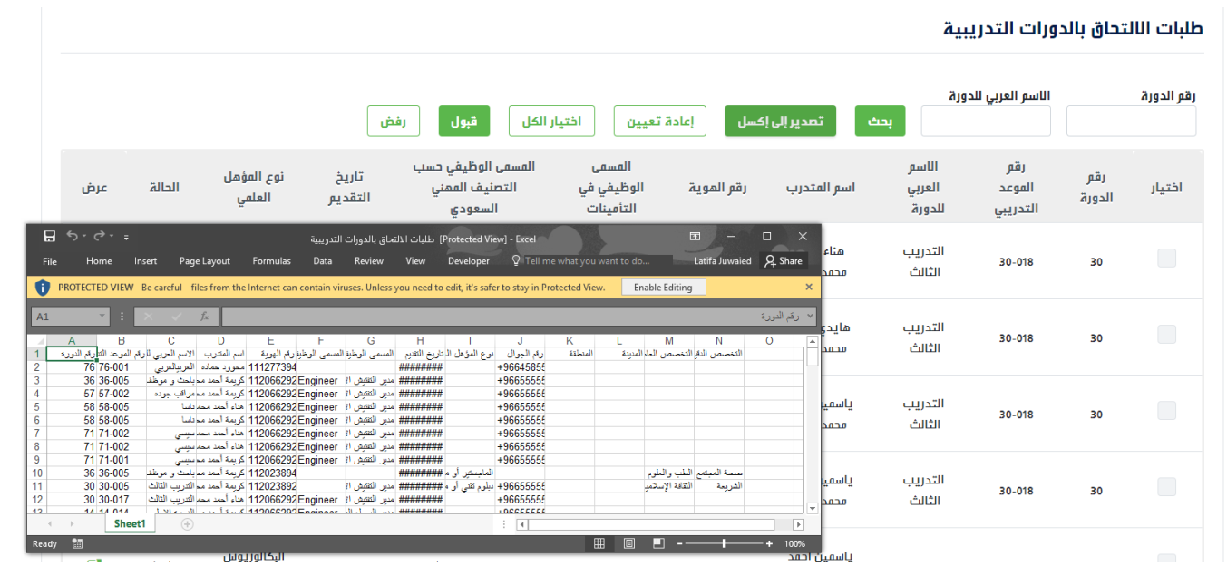

Training Management
Go to Our Programs > Maharat > Training Management
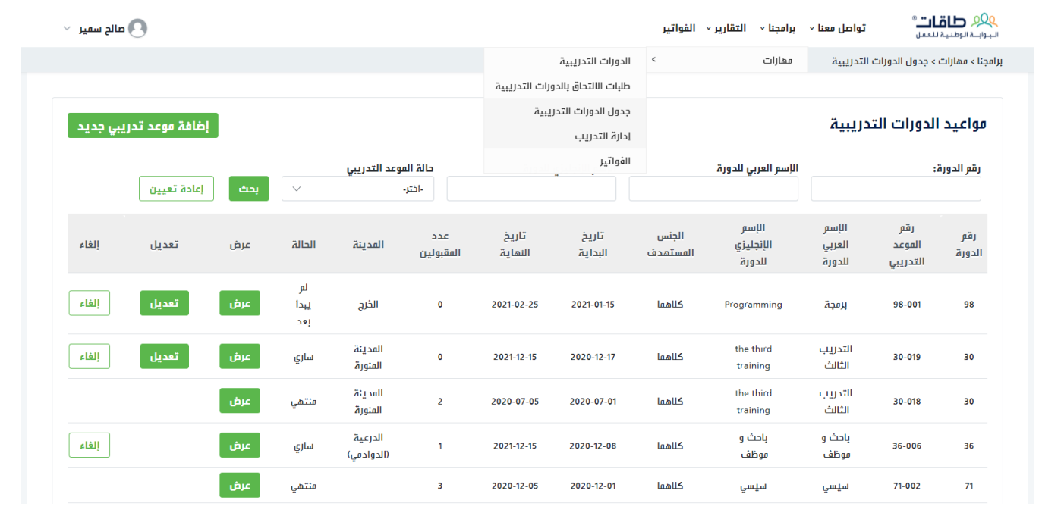

Training Management
View all courses and the status of each course
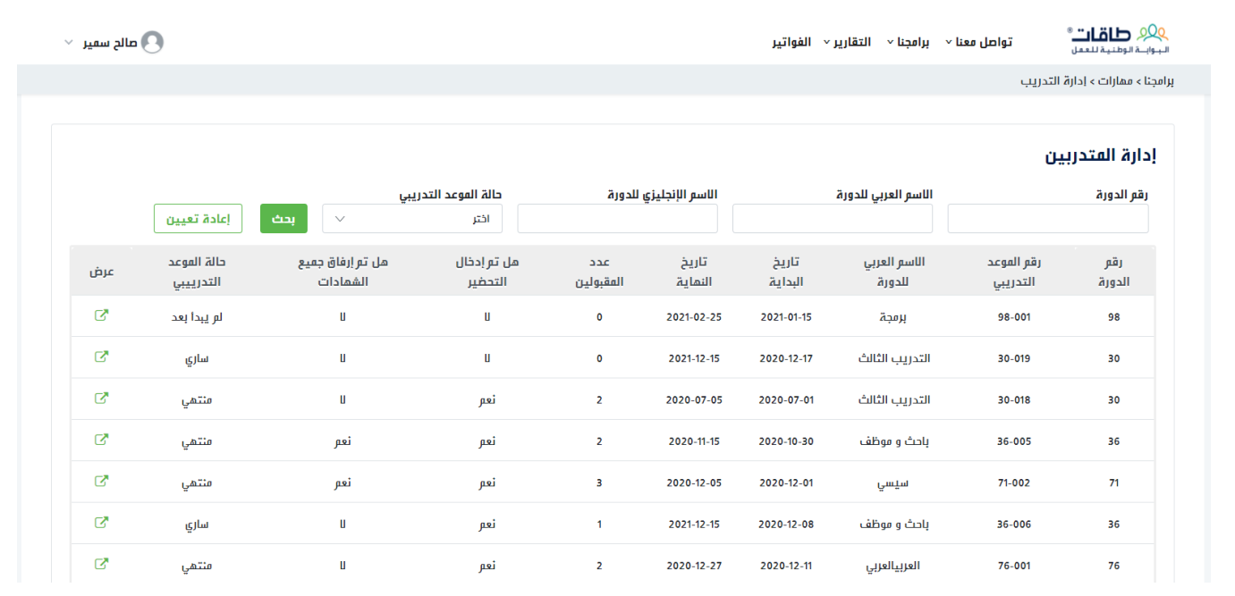

Training Management
Enter trainee attendance details, and save the edits
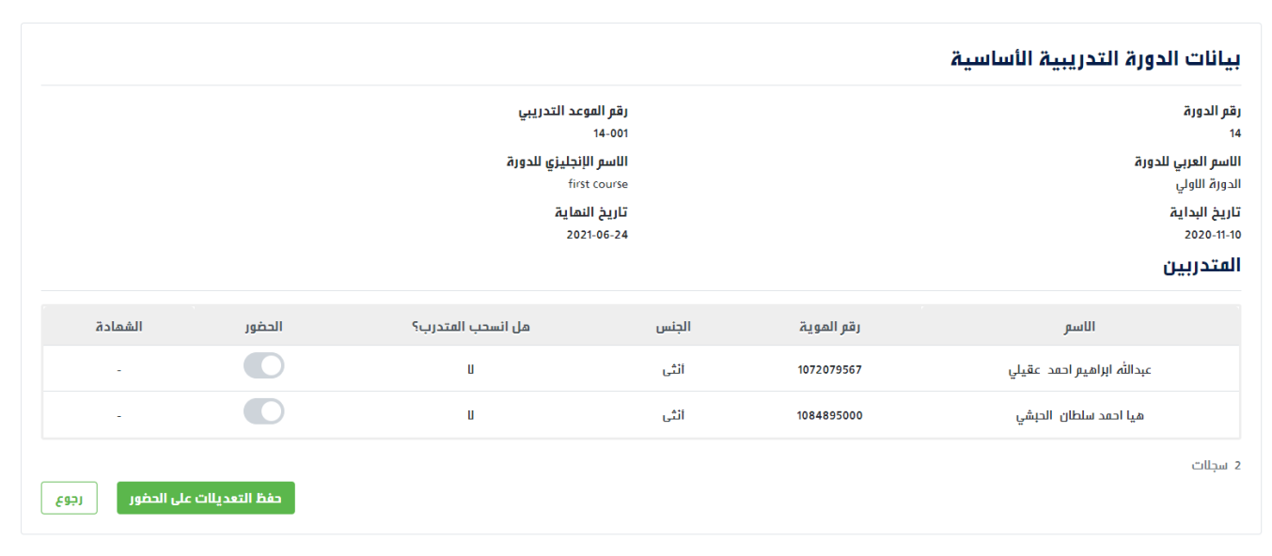

Training Management
Attach training certificates for all trainees
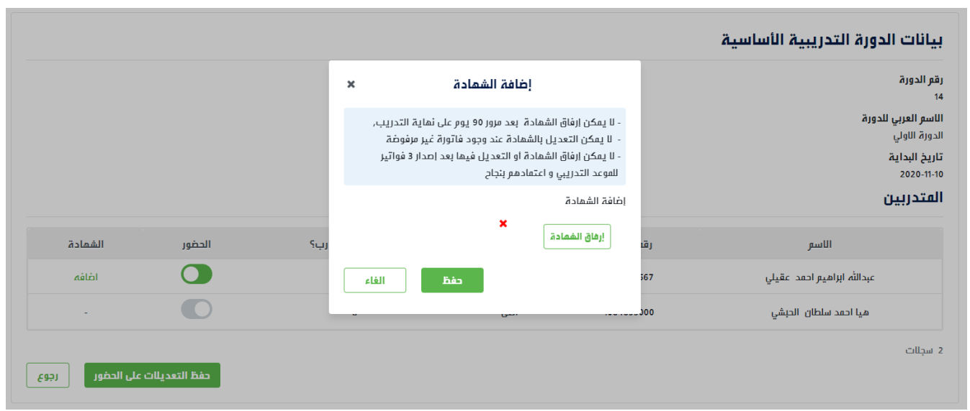

Training Management
Attach training certificates for all trainees
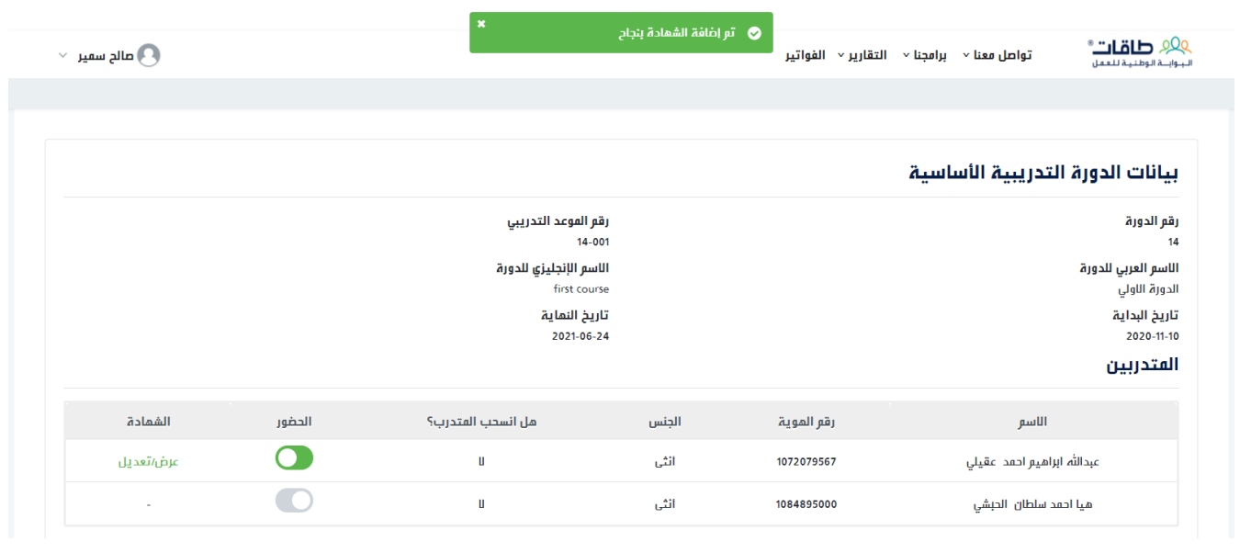

Training Management
Save attendance edits
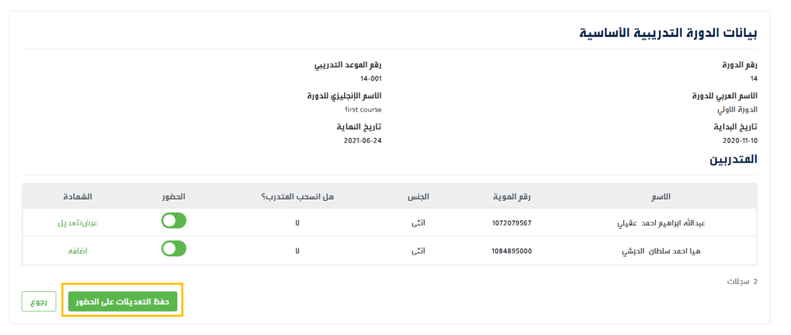

Training Management
The training course must be completed to enter attendance
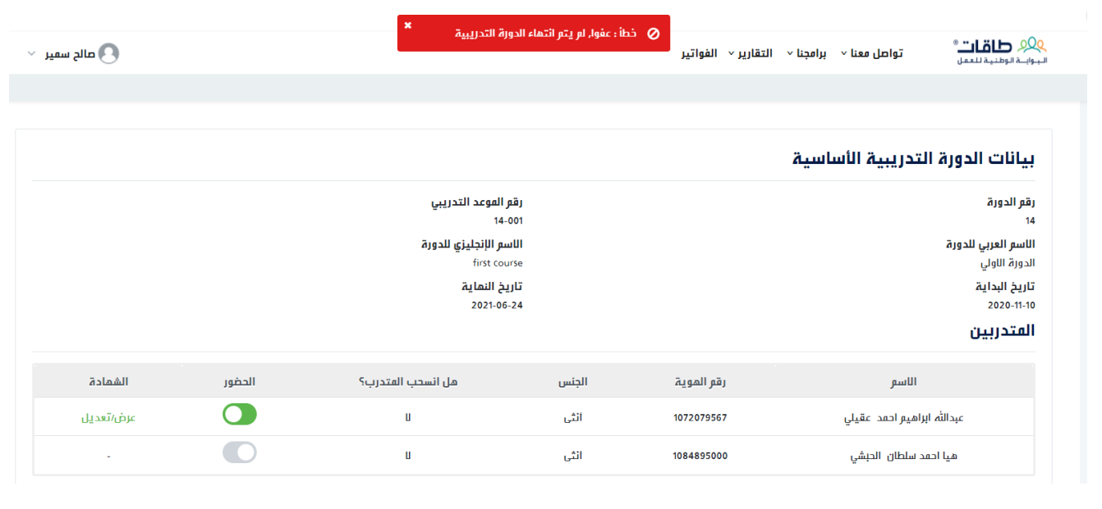

Invoices
Go to Our Programs > Maharat > Invoices
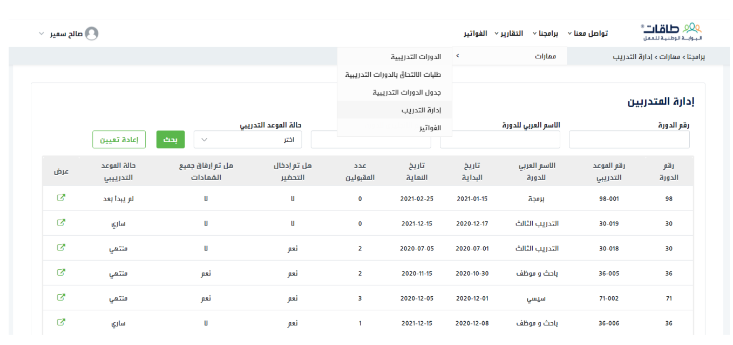

Invoices
Display the list of invoices.
To view the details of any invoice, you can select View.
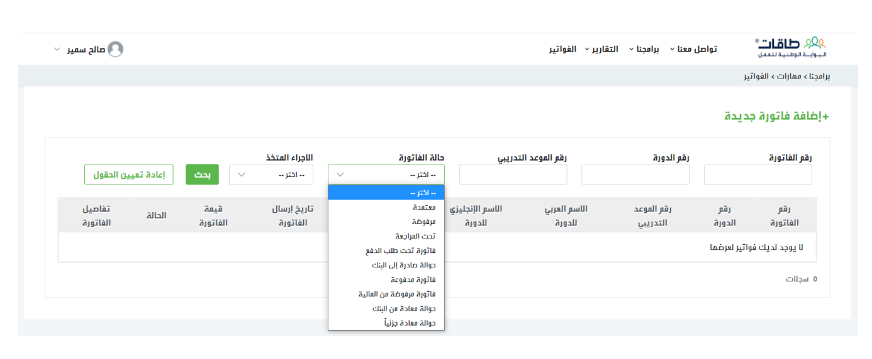

Invoices
Add a new invoice, course test, training date
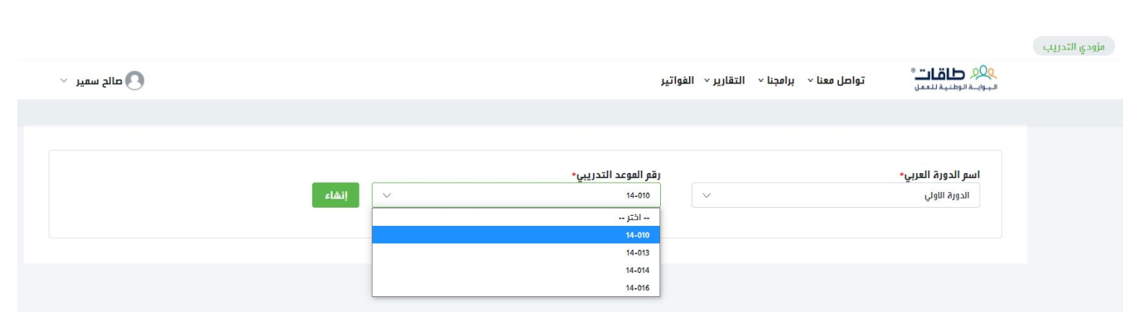

Invoices
Review invoice information before sending
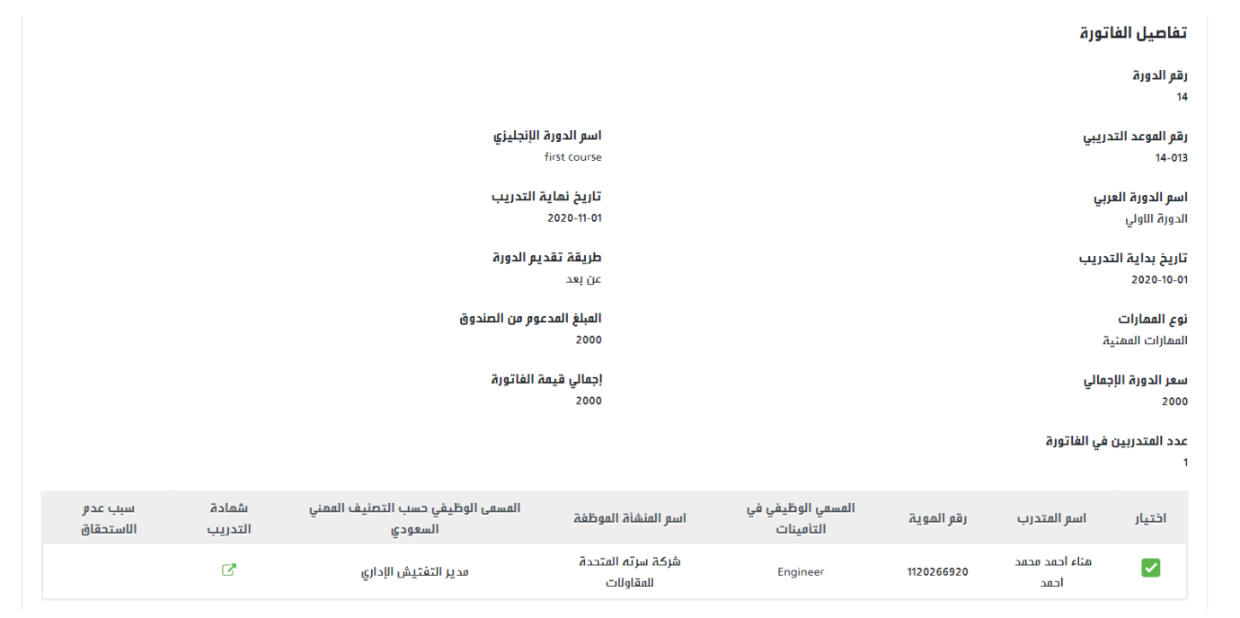

Invoices
Send the invoice to be Approved by the Program Administration at the Human Resources Development Fund (HADAF)
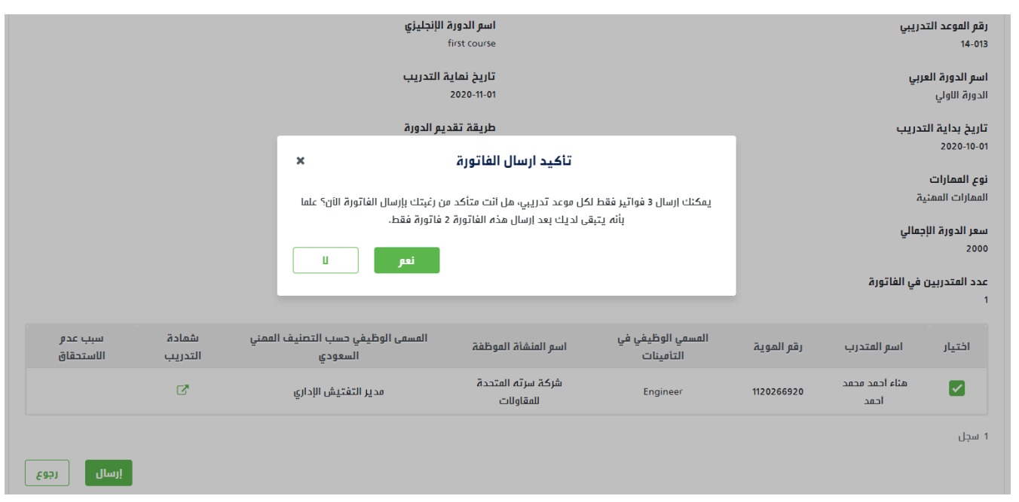

Invoices
The status of the invoice is "Under Review" until being approved.
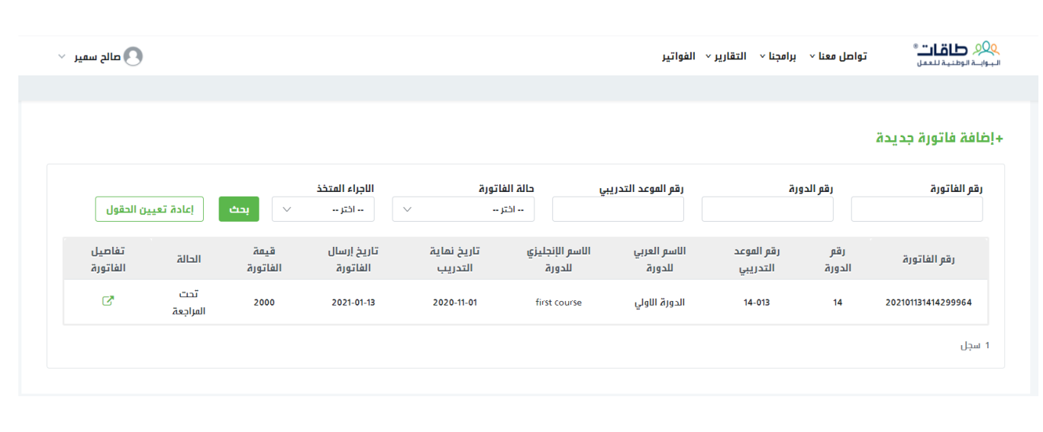

Invoices
After approval, the invoice status will be edited. All invoices and their status appear in Invoices
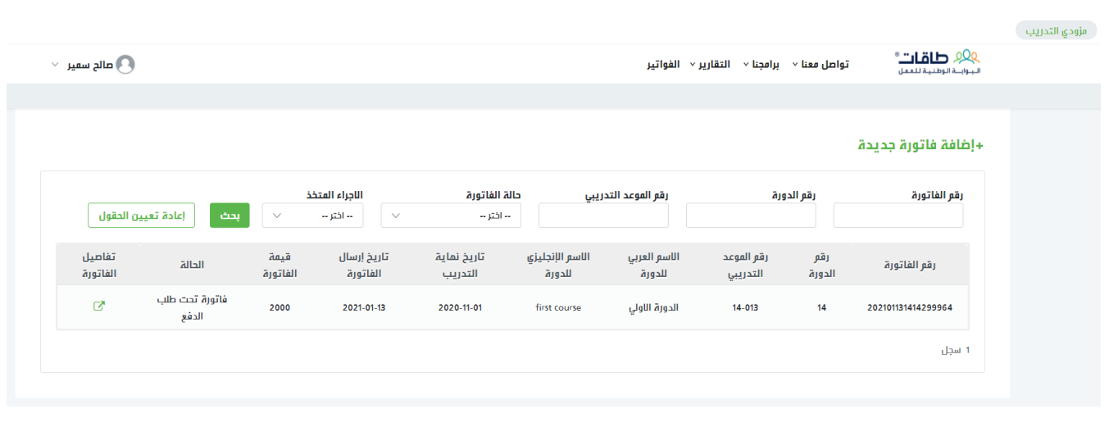

Invoices
After approval, the invoice status will be edited.
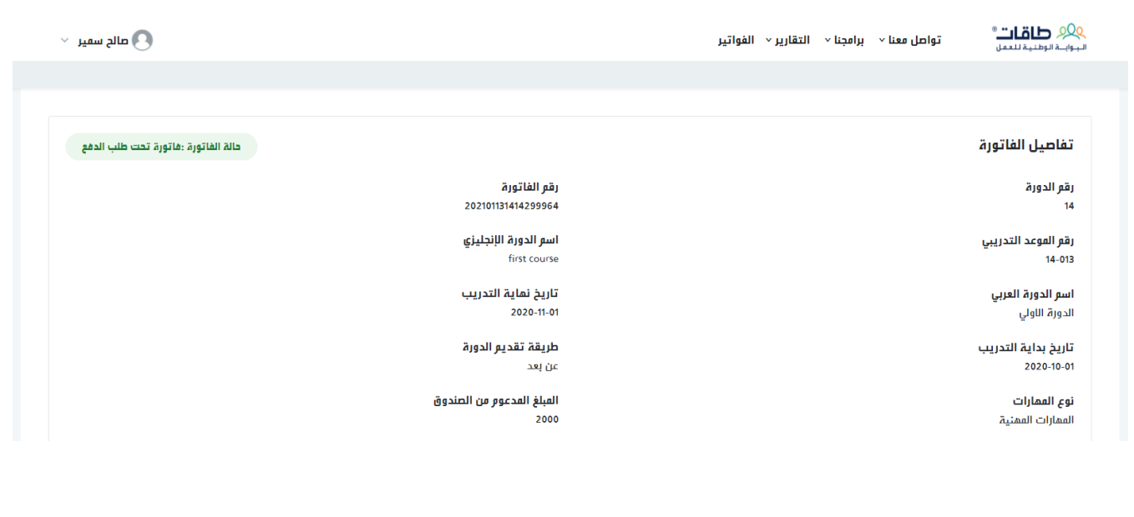

Invoices
If rejected, the reason for rejection is shown and the invoice can be resubmitted.
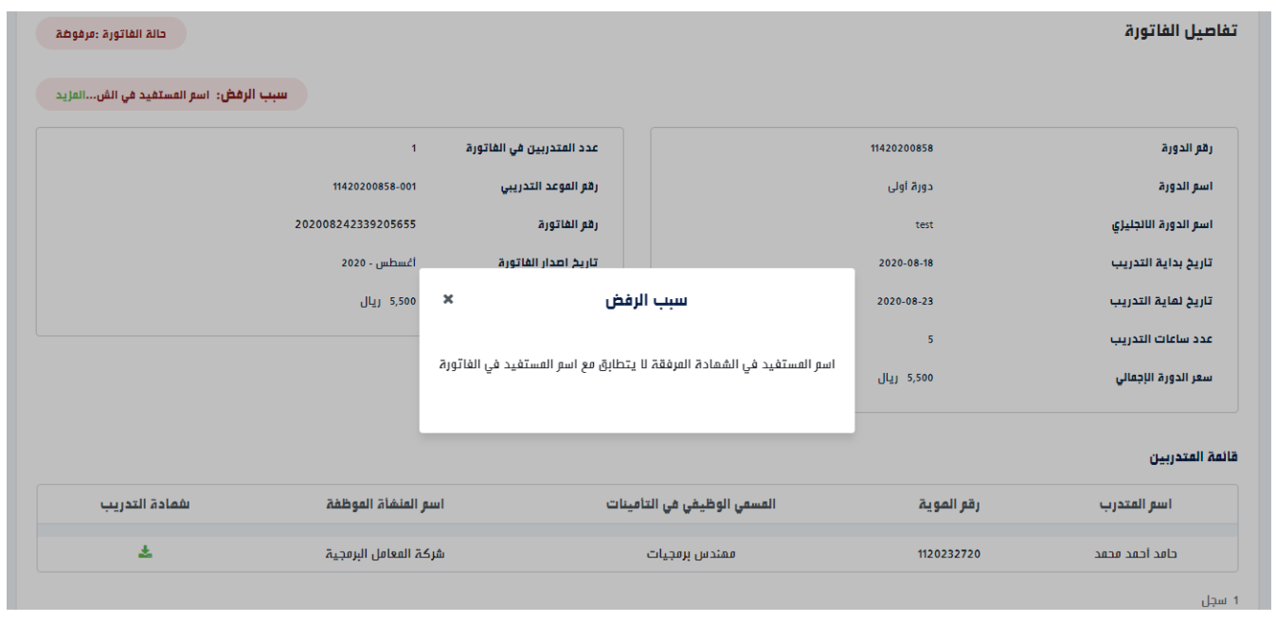

Reports
Go to Reports > Maharat > Maharat Program Report
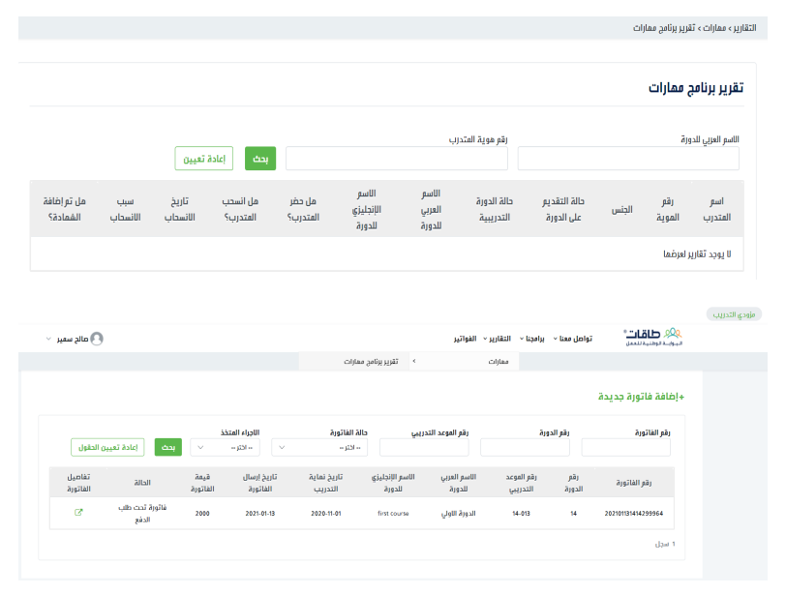

Reports
View all trainees and applicants with the training provider.
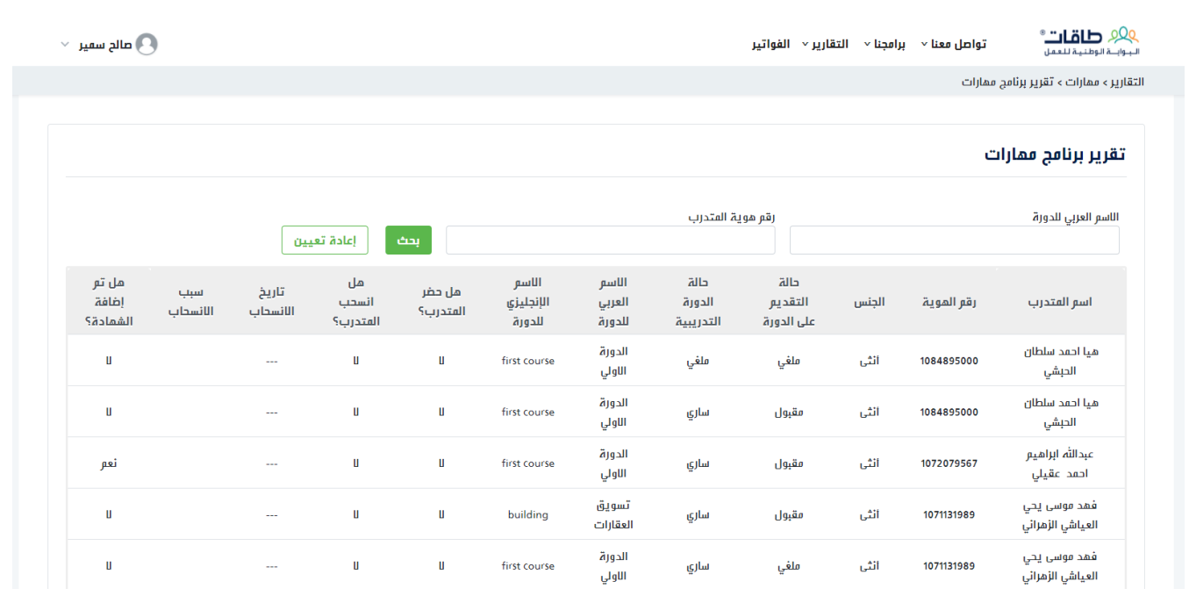

Thanks
February 2021

